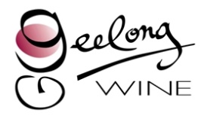
Bendigo Bank Geelong Wine Show Entry Form 2016
Entry forms and fees must be received by the close of business on Friday 30 September 2016. Please send all entry forms and correspondence to info@winegeelong.com.au and pay fees via EFT details below.

CLASS | VARIETY OR BLEND COMPOSITION % | VINTAGE | COMMERCIAL NAME OF WINE | RESIDUAL SUGAR IF REQ (G/L) | QTY STOCK (doz)
 |  | Number of entries: Financial GWA member |  | @ $45 per entry | $
 |  | Number of entries: Non-member / Non-financial GWA member |  | @ $70 per entry | $

DECLARATION - By entering I agree to be bound by the 2016 Geelong Wine Show Conditions of Entry and hereby certify that the entries comply with all the regulations as detailed on the wine show web site.
Exhibitor / Winery: Contact: Signature:
Address of Exhibitor:
Address where wines can be audited:
Phone BH: Mobile: AH: Email:
PAYMENT Please email completed form to info@winegeelong.com.au together with payment by COB Friday 30 September

Direct Debit Geelong Winegrowers Association BSB - 033-208 ACC NUMBER - 11-5182 (Please list winery name when paying)

